[Insert organisation name]
Scan4Safety business case

Date: [Insert document date]

Contents
Purpose 3
Contributors 5
Section 1: Scan4Safety business template 6
Section 2: Supporting information 14
1. Executive summary 14
Overview of the benefits from the Scan4Safety report 18
2. Strategic background 19
a. National strategic content 19
b. Local strategic content 27
3. Case for change 28
4. Overview of benefits 28
5. Economic case 30
6. Commercial case 30
Timeline for adoption of the core enablers 30
7. Financial case 32
How will it be made affordable? 32
8. Management case 34
Engagement messaging for key stakeholders 34

Purpose
The purpose of this document is to provide a tool for healthcare providers and other organisations to develop and articulate the business case for investment in Scan4Safety. The first section provides the outline of what may be included. The second section provides evidence/information to support the business case.
This document has been produced by the GS1 UK healthcare user group (HUG).

Scan4Safety
The Scan4Safety programme was launched in 2016 by the Department of Health and Social Care (DHSC). Six NHS trusts in England were tasked with implementing GS1 standards to uniquely identify every person, every product and every place within the supply chain and clinical pathways.
Ref: https://www.scan4safety.nhs.uk/
In 2016, the DHSC awarded a total of £12m to be distributed between the six hospital trusts. These Scan4Safety demonstrator sites were used to investigate how the consistent use of point-of-care barcode scanning might improve efficiency and safety within the NHS. The barcodes used were all compliant with GS1 standards. These standards were chosen because they guarantee that a barcode is globally unique and also that it is both system and device agnostic, ensuring interoperability with a full range of devices and computer systems.
About GS1 UK
GS1 is an independent body which provides globally recognised open standards, and related products and services, to support business communications locally and globally. GS1 has 116 not-for-profit Member Organisations operating across 150 countries, supporting more than two million members worldwide. Developed and maintained collaboratively by industry users, GS1 standards provide a common language to be shared between and within organisations, helping them improve performance and traceability. GS1 UK supports more than 58,000 members across a variety of sectors, including retail and healthcare.
About the GS1 UK healthcare user group (HUG)
The HUG is made up of invited senior representatives from healthcare trade associations, providers, suppliers, solution and service companies, and other related organisations. Its purpose is to promote the adoption of GS1 standards throughout UK health systems, by suppliers, partners, and in line with regulatory requirements.

Contributors
Name | Role | Organisation
Rachael Ellis | Scan4Safety director | Hull University Teaching Hospitals NHS Trust
Dave Harris | Head of service – logistics and supply chain | Lancashire Procurement Cluster
James Mayne | Programme manager and Scan4Safety lead | University Hospitals of Derby and Burton NHS Foundation Trust
Richard Price | Scan4Safety programme & ICT procurement manager | University Hospitals Plymouth NHS Trust
Marc Saaiman | Deputy head of procurement and Scan4Safety lead | South Tees Hospitals NHS Foundation Trust
Mark Stevens | Head of purchase to pay | Manchester University NHS Foundation Trust
Andrea Smith | ICS procurement director | Sheffield Teaching Hospitals NHS Foundation Trust
Simon Walsh | Group procurement director | Manchester University NHS Foundation Trust
Jackie Pomroy | Independent consultant
George Lawton | Engagement manager | GS1 UK
Juliette New | Engagement manager | GS1 UK
Natasha Smith | Marketing manager – healthcare | GS1 UK

Objective
The objective of this document is to help stakeholders respond to four key steps in their business case:
- Scan4Safety and the benefits of adopting GS1 and PEPPOL standards
- Requirements to instigate and sustain adoption
- Benefits that can be expected from Scan4Safety implementation
- Quantifiable costs and benefits

Section 1: Scan4Safety business template
Heading | Action | Content links
- Executive summary
This section is a brief resume of the main elements of the business case. Complete this section once the remainder of the template has been completed. |  | Executive summary
Background and overview | This section should include a summary of:  - Background  - Overview of GS1 and GS1 standards  - Scan4Safety programme: core enablers and primary use cases  - Overview of the benefits from the Scan4Safety report  - Include link to the NHS trust’s own digital strategy and include references to where Scan4Safety can be/is to be built into digital processes  - Include trust Never Event numbers and details of the types of Never Events seen throughout the trust. Explain how Scan4Safety can be used to reduce them by making investigations simpler and more accurate. Supporting information can be found in the executive summary section.  - Does the NHS trust’s CQC report make any specific recommendations and can these be related to where Scan4Safety can help?  - Include a review of your “quality summary” or “quality statement” and any selected reasons as to why this might have a benefit against the points raised. These are the key focus points and resources that will be in place against this document’s headlines, supported by the executive board. Can cany of the points be matched to solve any of the problems?
- Strategic background
This section includes national legislation, policy and evidence, and local content |  | Strategic background
National strategic content | This section includes the following information:  Evidence  - Independent Medicines and Medical Devices Safety Review (IMMDSR) – First Do No Harm, 2020  - DHSC report, Oct 2020: Transforming NHS Pharmacy Aseptic Services  - HSSIB safety reports  Legislation  - Medical Device Regulation 2002 and MHRA public consultation 2022  - Medicines and Medical Devices Act 2021  Policy/National strategies  - DHSC NHS eProcurement Strategy, 2014  - Lord Carter review, 2016  - Digital Clinical Safety Strategy, 2021  - What Good Looks Like (WGLL) framework, 2021  - NHS England Outcomes Registries Programme and the Medical Device Outcomes Registry (MDOR), 2022  - DHSC medical technology strategy, 2023  - NHSE seven digital priorities, 2023  - NHS Supply Chain inventory management and point-of-care solutions plan, 2023  - The government’s barcode scanning mandate to NHS England, 2023/24  - NHS England Strategic Framework for NHS Commercial, 2023  - NHS Supply Chain Data Standards – Supplier Product Coding Policy, 2024 | National strategic content
Local strategic content | The local section allows you to present an overview which includes:  - Organisations and healthcare services covered by the proposed investment  - Local strategic drivers for the investment (which may be tied to the legislation/policy outlined above)  - Existing programmes of work that are already in place  This section should also include a definition of what internal factors or challenges are driving the change. | Local strategic content
- Case for change
In this section, summarise specific gaps or weaknesses in your existing arrangements using the relevant areas below:
People and teams | Supply chain resources  Consider staff resource requirements:  - Supply chain team working in partnership with procurement  - Estimated resource cost (pounds and FTE)  - Comparative analysis of current roles and perception of requirements vs actual need  Clinical resource  - What clinical time is currently spent on manual stock control?  - How much of this time could be released back to patient care through Scan4Safety?  - What is estimated resource cost difference between supply chain team and clinician?  Stock management resource  - Is the current stock management process fragmented? e.g. is there a materials management team in each department?  - What would be the benefits of a standardised approach using Scan4Safety principles?  Training resources  - Consider existing staff resource availability to create tools/communications and a formal training programme  - Consider any additional training resource costs
Patient care and product / medicines / equipment traceability | Patient care  - Quantify any cancellations/delayed procedures due to lack of availability of products for patients (Use Datix reports or similar for this evidence)  - Quantify the number and type of serious untoward incidents of implanted products (Use Datix reports or similar for this evidence)  - Estimate the amount of clinical time spent on administrative tasks vs direct patient care (what proportion of time in a given set period is spent on each for comparison?)  - Is the current process completely manual e.g. manual recording of implanted products to patients, or manual dispensing, prescribing, or administration of medicines?  Product, equipment and medicines traceability  - Product recall – Is there a central policy and process in place to drive resources and govern the reporting and resolution of issues?  - For any product recall, estimate the time spent on manual processes including searching for and through physical records and contacting patients?  - What is the process for yellow card reporting for medicines and products? How can it be improved using GS1 standards?  - If known, consider how many dispensing or administration errors occur, or the types of errors that occur and that could be minimised.  - How is equipment availability and maintenance monitored? Can GS1 standards/RFID be used to help improve traceability? What is the risk of continuing with a current manual process? E.g. error in recording keeping  - Are you currently meeting the regulations outlined in section 2.2 below?  Stock and wastage  Provide information on current stock levels and wastage levels  Consider wasted and expired product which is being disposed of within clinical waste. How does this impact approximate disposal costs?
Data | - Accuracy of data  - Access to complete data  - Multiple data entries  - Lack of timely clinical data available during patient contacts leading to unnecessary referrals or admissions  - Limited interoperability between systems reducing availability of data and increasing multiple entry to data  - Lack of traceability  - Auditing challenges  - Different uses of product data  - Inaccurate patient level costing  - Limited analysis of clinical variance  - Qualitative benefits, e.g. manual intervention, duplication of effort, barriers to analysis and transformation
Processes | - Time consuming administrative processes  - Clinical inefficiency – releasing time to care  - Manual processes
Current systems | How do your current information systems underpin the areas covered by the proposed investment?  - Systems affected – potential version upgrades  - New systems adoption  - Interoperability – systems that may need to interface with other systems  - Are current systems GS1 UK Approved?
- Overview of benefits
This section provides details of the benefits under the following headings
Investment benefits | - Patient level costing  - Reduction in inventory  - Reduction in wastage  - Purchase to pay efficiency | Overview of benefits table
Patient safety benefits | - Product recall  - Reduction in Datix  - Positive patient ID supporting reduction in harm  - Patient location – knowing where the patient is at any time | Overview of benefits table
Better quality care | - Reduction in clinical errors  - Product availability – inventory and assets | Overview of benefits table
More efficient working practices | - Operational efficiency  - Time efficiency  - Procedure capture  - Automation of processes  - Asset rationalisation  - Audits  - Admin  - Estates space management  - Readily available data and reports | Overview of benefits table
Operational benefits | - Inventory control and visibility  - Reduction in annual stock take costs and accurate stock valuations  - Consignment stock management  - Digitisation - Reduced manual entry  - Staff motivation – skills and development | Overview of benefits table
- Economic case
This section outlines options for the economic case
Proposal options | - Do nothing*  - Do minimum – managed adoption, one use case  - Full adoption – GS1 standards for patient, product, and place adopted across all wards and departments  Determine the options and undertake SWOT (strengths, weaknesses, opportunities, threats) analysis.  Identify the preferred way forward for the programme – scope, solution, service delivery, implementation and funding – together with the shortlist of options against which the preferred way forward will be appraised.  *”Do nothing” means the following:  - Not compliant with requirements of Medical Device Regulation  - No cost savings or benefits would be realised  - Future transformational benefits impacted without implementation of core enablers and use cases  - Patient safety incident reduction impacted  - Clinical resource continues to be impacted as it is required to manage inventory  - Increased and ongoing wastage
Risks | Specify the main risks associated with the achievement of the programme and propose counter measures for avoidance, mitigation and management.  Include the main risks here:  - Funding  - Culture and governance  - Communication  - Change management and leadership  - Support from senior stakeholders  - System adoption/Solution provider engagement  - Clinical engagement  - Supplier engagement  - Dedicated supply chain team  - Baseline benefits  Consider here that the biggest risk may be NOT implementing the programme.
- Commercial case
Stakeholders and resource | Identify the following:  - GS1 lead  - Director level steering group  - GS1 implementation manager  Programme management team should include:  - CIO/CCIO/CNIO roles  - Clinicians  - Procurement  - Estates  - IT  - Finance  - Transformation team  - Communications  - Information governance  - Pharmacy  - Administration – leadership skills that can drive and implement business change  - Project support  - Coding / Commissioning colleagues | Commercial case
Programme timeline | Planning phase  - Senior responsible officer (SRO) on exec board  - Clinical engagement  - Establish a governance board  - Consider programme resource  - Adopt core enabler/s if not enabled – see core enablers in appendix section  - Identify use case/s for GS1 standards adoption – see use cases in appendix section  - GAP analysis/As is to be/ Time and motion studies  - Benefits analysis using Scan4Safety benefits calculator  Stage 1 – Implementation of GS1 identifiers and barcodes for products, places and patients which are termed the core enablers  Stage 2 – Implementation of GS1 standards in purchase to pay, inventory management, and product recall, which are termed the primary use cases  Stage 3 – Implementation of GS1 standards in further use cases | Commercial case
Solution provider engagement | Engagement with current providers of systems for the relevant use cases is key.  - Ensure that solution providers are GS1 UK-Approved partners – Partner finder  - Ensure that GS1 guidelines are shared for relevant use cases | Commercial case
Healthcare supplier engagement | Healthcare supplier engagement to drive GTIN and GLN adoption in catalogue management to include the following:  - Ten step guide for suppliers/How-to adoption guide – the full guide can be found here  - Healthcare supplier GS1 member mapping – the GS1 UK healthcare team will support. Email healthcare@gs1uk.org. | Commercial case
- Financial case
Funding | Determine how the programme is to be funded:  - Healthcare provider funded  - Regional / ICS funded  - Joint funding | Financial case
Source | Identify the source of funding
How it will be made affordable? | Complete the benefits calculator | Benefits calculator
- Management case
Programme and project management governance arrangements | Plan programme management – strategy, framework and plans.  Record the risk profile assessment (RPA) and SRO for the programme.  Set out the governance arrangements, including key roles and responsibilities.
Project management | Ensuring project lead is reporting to SRO and all relevant departments represented in the project group for implementation.
Governance | Governance of GS1 standards and programme outlined and standard operating procedures (SOPs) for departments included in the implementation plan.
Engagement plan | Communication plans developed and included for key stakeholders and all organisation employees. | Stakeholder engagement and messaging

Section 2: Supporting information
- Executive summary
Brief resume of main elements of the business case. Complete this section once the remainder is complete.
This section should include a summary of:
Background
Please insert a short overview of your objectives and the case for change. Further details can be provided in the segments below.
Overview of GS1 and GS1 standards
In UK healthcare, GS1 standards have been proven to improve patient safety and enhance clinical effectiveness by reducing unwarranted clinical variation and drive operational efficiencies, irrespective of clinical settings. This is achieved by creating unique identifiers for every person, every product, and every place, allowing data to be captured consistently and accurately at the point of interaction and shared across supply chains up to the point of care.
The introduction of the Medicines and Medical Devices Act (MMDA) (February 2021) will further encourage the use of GS1 standards in healthcare. In particular, the Medical Device Register (MDR), in development by the Medicines and Healthcare products Regulatory Agency (MHRA), will ensure that eligible medical devices used in the UK are registered with key information, by the manufacturer in one central registry. The Surgical devices and Implants Information system (SDIIS) being developed by NHS Digital as part of the National Perioperative Data Standard Programme is instrumental to this. The use of GS1 standards will facilitate the efficient track and trace of medical devices to patients, as well as capturing details of the place where the procedure occurred, and which clinicians were involved. This also supports information required for the NHS England Outcomes and Registries programme and the proposed Medical Device Outcomes Registry (MDOR)..
GS1 UK has established multi-year partnership agreements with healthcare governing bodies across the UK to increase the adoption of GS1 standards across health systems. This approach supports the strategic aims for each of the four nations, where the implementation of open data standards in healthcare will enable traceability and interoperability – allowing information to flow seamlessly between systems and organisations.
In 2016, the UK’s Department of Health and Social Care (DHSC) launched the Scan4Safety programme – a pioneering initiative designed to enable the delivery of better and safer patient care, improve clinical productivity, and drive supply chain efficiencies across England’s National Health Service (NHS).
As part of the programme, six NHS trusts were given a share of £12m to implement standards for identification (GS1 standards) and messaging standards for electronic data interchange (PEPPOL). This programme now sits with the NHS England Medical Directorate team, supporting trusts with rolling out Scan4Safety programmes of work.
GS1 standards were integrated into each of the trusts and centred around three core enablers for unique identification:
- People – GS1 Global Service Relation Numbers (GSRNs)
- Products (medicines, medical devices, equipment) – GS1 Global Trade Item Numbers (GTINs) for medicines and devices; or GS1 Global Individual Asset Identifiers (GIAIs) and Global Returnable Asset Identifiers (GRAIs) for assets/equipment
- Places – Global Location Numbers (GLNs)
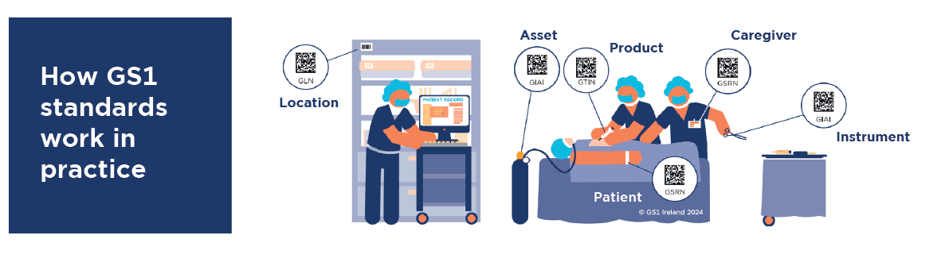
After two years, the Scan4Safety programme successfully reached completion. In July 2020, the evidence gathered throughout its duration was published into a finalised report entitled “A scan of the benefits: the Scan4Safety evidence report”.
The achievements exhibited by the six demonstrator sites involved in the programme, provide a clear business case for the widespread adoption of point-of-care scanning in healthcare.
Never Events
Each year, NHS England reports on the numbers and types of Never Events that have taken place across the NHS. A Never Event is defined as: “patient safety incidents that are wholly preventable where guidance or safety recommendations that provide strong systemic protective barriers are available at a national level and have been implemented by healthcare providers”.
From 1 April 2022 – 31 March 2023, NHS England reported a total of 384 Never Events including:
- 169 Wrong site surgeries
- 96 Retained foreign objects post procedure
- 42 Wrong implant prosthesis
- 31 Misplaced naso- or oro- gastric tubes
- 16 Administration of medication by the wrong route
Additional types of Never Events for 2022/23 can be found in the full report summary. For current data, all reports on Never Event incidents can be found on the NHS England website.
Using GS1 standards provides clinicians with real time access to trusted, accurate, event data of the patient, the clinician involved, details of the product used or medication administered, and when the event took place.
This traceability improves patient safety by preventing Never Events such as:
- Medication errors
- Wrong site surgeries
- Wrong implant or prosthesis
- Retained foreign object post-surgery
- Misplaced oro- or naso-gastric tubes
By scanning GS1 barcode pertaining to the required person (patient or clinician), product/asset, or place, directly at the point of care enables this information to be captured in real time. This prevents unwarranted errors due to real-time patient alert notifications and enables accurate record keeping – helping clinicians to get it right first time.
Scan4Safety programme: Core enablers and primary use cases
- Patient identification
The DCB1077 standard requires NHS trusts to adopt GS1 barcoding standards for use on patient identity wristbands. This is to enable accurate identification of the patient, with barcode scanning facilitating the upload of clinical data into the electronic patient record. GS1 standards enable electronic records to be created that capture details of the patient, caregiver, care location, and equipment and consumables utilised during an episode of care, facilitating clinical audit and product recall. NHS trusts should use the national NHS number and not the medical record number (MRN) to prevent errors when matching records between hospitals. See reference to HSSIB reports in legislation section.
- Location numbering (GLN)
GS1 provides the Global Location Number (GLN) standard for the identification of unique locations, such as:
Legal entity | A healthcare provider organisation or a supplier
Functional entity | Cost centre or accounting office
Digital location | Electronic address in the cloud for sharing business messages
Physical entity | Hospital or warehouse
GLNs support each use case by enabling an event to be matched to a location, whether this relates to a person, asset, product or service.
- Catalogue management
Suppliers are required to place standardised master product data into a GS1-certified data pool. The GS1 Global Data Synchronisation Network (GDSN) links these data pools. This enables hospitals to draw supplier master data from the data pools into their local catalogue solution. This process will ensure that accurate and consistent product information is used across the NHS and its supporting supply chains.
Primary use cases
- Product recall
Legislation requires hospitals to be able to electronically track and trace medical devices to individual patients. Scanning barcodes on the patient wristband and on the device, into the patient record, enables product safety recalls to be managed effectively. This facilitates the prompt recall of affected patients upon receipt of a product recall notice, together with the timely identification and isolation of faulty products.
- Purchase to pay (P2P)
The use of PEPPOL messaging standards supports the electronic transfer of information between trusts and suppliers without manual intervention. Together with the GS1 coded product information, this enables automated matching of order, invoice and delivery notification speeding up subsequent payment. The accuracy and automation of barcodes reduces costs in requisitioning, ordering and payment.
- Inventory management
Many products provided by suppliers to the NHS already carry GS1 barcodes and, all products will be required to comply with this requirement. These barcodes can be used to manage inventory in all locations around a hospital, from central stores to local stock rooms in wards and departments. Scanning the barcode enables key data to be captured electronically and exchanged without manual intervention, directly into patient administration and purchase order processing systems.
- eMedicines
The use of solutions such as robotic dispensing can utilise barcodes for input into the storage area and retrieval for dispensing. The use of GS1 standards for medicines can provide access to product information and enable process controls to ensure the efficient management of pharmaceuticals. Hospital pharmacy manufacturing units can assign GS1 barcodes in the same way as commercial manufacturers to enable automated data capture processes within the hospital.
- Surgical instrument tracking
GS1 barcodes can be etched onto individual surgical instruments and trays so that when used on patients or passing through sterilisation processes, they can be scanned and recorded. This enables events around individual instruments to be accurately monitored and any restrictions on usage to be strictly complied with. Complete trays can be tracked and traced using GS1 barcode labels.
- Asset management
GS1 barcodes can be applied to individual items of medical equipment, enabling equipment to be identified and tracked in and out of equipment libraries and point-of-use locations. This leads to improved equipment utilisation, greater scheduled maintenance compliance and better equipment availability. At the point of care, use of the equipment can be associated with the barcoded patient wristband.
- Medical records
Medical records can be identified with a unique GS1 barcode or RFID tag. Coupling the GS1 barcode with GS1 location number information (using a GLN), and uploading that to the medical records management system, enables the accurate tracking of medical records throughout the entire hospital estate. This leads to improved patient care by having records to hand and improves efficiency by reducing time taken to locate specific records.
- Pathology sample management
GS1 standards can be used to accurately track samples from patient to laboratory, reducing the incidence of lost samples and helping to make results available as quickly as possible. Through scanning each barcoded sample along with the GLN, progress can be recorded through to use in patient diagnosis.

Overview of the benefits from the Scan4Safety report
Benefits have been realised in two key areas:
- Patient safety: Through complete traceability; speedy and accurate recall; the reduction of drug errors and Never Events; improving routine observations and patient identification
- Cost and efficiency savings: Through more efficient and cost-effective product ordering; happier, more efficient staff; the creation of accurate patient level costings; reductions in unwarranted variation

Among the headline findings:
- 140,000 hours of clinical time have been released to care
- Recurrent inventory savings worth nearly £5m across the six trusts
- Non-recurrent inventory reductions have amounted to £9m
- At Leeds Teaching Hospitals NHS Trust, the average time taken for product recalls has fallen from 8.33 days to less than 35 minutes following the introduction of Scan4Safety. The organisation estimates it will save £84,411.07 each year on such recalls.
- By introducing scanning in pharmacy, Royal Cornwall Hospitals NHS Trust reduced prevented-error rates by 76 per cent, including the elimination of all errors caused by wrong patient, wrong drug, wrong dose, and wrong form
Outside of the programme, several NHS trusts have since embarked on their own adoption journeys, shaping the Scan4Safety blueprints for widespread implementation.

- Strategic background

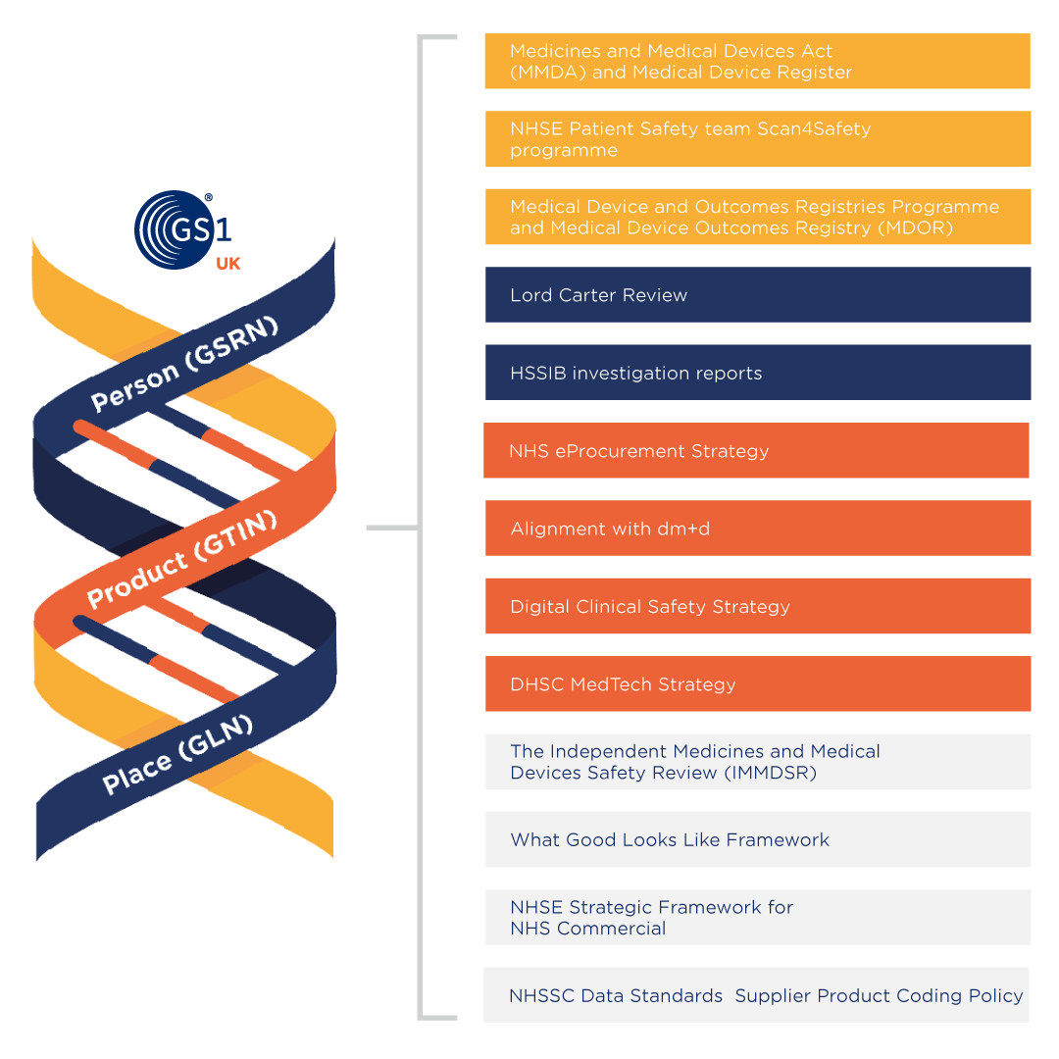
The main outcome of this part of the case should be a set of objectives which in essence define what the proposed project is about. These will be derived from information about the organisation and its needs, and the strategic context it operates in.
- National strategic content
Evidence
- Independent Medicines and Medical Devices Safety Review (IMMDSR) – First Do No Harm
In 2018, the former secretary of state for health and social care, The Rt. Hon. Jeremy Hunt MP, called for a review that would examine how the healthcare system has responded to concerns raised by patients and families about three medical interventions:
  - Primodos (a hormone pregnancy test)
  - Sodium Valproate (an anti-epileptic drug)
  - Surgical mesh
In 2020, the findings from The IMMDS Review, also referred to as The Cumberlege Review, were published along with nine recommendations for improvements. Two of these recommendations can be supported by the adoption of GS1 standards and are underpinned by the need for unique identification.
Recommendation six references the need for traceability and greater post-market surveillance of products available in GB; and recommendation seven to create a national patient-identifiable database which links medical device information to the patient.
In response to these recommendations, The Government is working to implement solutions based on these requirements.
- DHSC report, Oct 2020: Transforming NHS Pharmacy aseptic services
In 2020, in a report commissioned by the Minister of State for Health, The DHSC published a report on the “service providing sterile, controlled environments for the preparation of injectable medicines into 'ready to administer' (RtA) formats for patients”. Conducted by Lord Carter of Coles, the review was titled “Transforming NHS Pharmacy Aseptic Services in England”.
The report identified efficiencies that can save one million bed days and 4,000 whole time equivalent (WTE) staff every year – highlighting the benefits of using ‘ready to administer’ medicines. In RtA forms, this will provide nurses with access to a wider range of standardised pre-prepared medicines to facilitate administration and reduce the risk of errors.
The recommendations of the report suggest investing in hubs “to produce aseptic injectable medicines in England in order to create high volumes of aseptic pharmacy products to save time for nursing staff, enable care closer to home, and produce significant savings”.
The report states: “Working with Royal Colleges and pharmacy specialists develop national guidance for standard injectable medicines. The specification for dose banded chemotherapy products will be agreed, along with parenteral nutrition and antimicrobial medicines. The standard specifications (concentrations, presentation, volume, expiry time post preparation, labelling and coding in line with the NHS Dictionary of Medicines and Devices (dm+d) and GS1 barcoding standards). NHS commissioning policy should explicitly support use of standardised products.”
This recommendation underscores the importance of GS1 standards use for traceability – firstly, by aligning with dm+d for the accurate identification of medicines and secondly, the use of GS1 UK’s LocationManager to provide visibility of medicines supply through accurate location identification.
Longer term, the report looks to accelerate the closed-loop medicines administration (CLMA) rollout within hospitals. Its purpose is also proposed to address the more than 237 million medication errors made every year in England – the avoidable consequences of which costs the NHS in England upwards of £98 million and more than 1700 lives every year. As cited in Prevalence and economic burden of medication errors in the NHS in England, 54% of medicines-related harm occurs at the administration stage, with close to 10 million errors a year causing moderate to severe patient harm.
- Health Services Safety Investigations Body (HSSIB – formerly HSIB) reports
The HSSIB came into operation on 1 October 2023 and is a fully independent arm’s length body of the Department of Health and Social Care. The organisation serves to investigate patient safety concerns across the NHS in England and in independent healthcare settings where safety learning could also help to improve NHS care.
Formerly the Healthcare Safety Investigation Branch (HSIB), the organisation’s investigations aim to reduce patient harm and identify areas of improvement. In several instances, the HSSIB have cited Scan4Safety adoption as a preventative measure to reduce the risk of harm to patients through unique identification and traceability.
Reports cited include:
- Detection of retained vaginal swabs and tampons following childbirth
- The selection and insertion of vascular grafts in haemodialysis patients
- Access to critical patient information at the bedside
- Decontamination of surgical instruments
- Electronic prescribing and medicines administration systems and safe discharge
Overview reports include:
- A thematic analysis of HSIB's first 22 national investigations
- Never events: analysis of HSIB's national investigations
Legislation
- Medical Device Regulation 2002 and MHRA public consultation 2022
Medical Device Regulation 2022
The regulation of the medical devices market in Great Britain (England, Wales and Scotland) is as follows:
Currently, devices are regulated under:
- Directive 93/42/EEC on medical devices (EU MDD)
- Directive 90/385/EEC on active implantable medical devices (EU AIMDD)
- Directive 98/79/EC on in vitro diagnostic medical devices (EU IVDD)
These directives are given effect in UK law through the Medical Devices Regulations 2002 (SI 2002 No 618, as amended) (UK MDR 2002). Schedule 1 of the Medical Devices (Amendment etc.) (EU Exit) Regulations 2020 sets out the specific requirements for Northern Ireland.
The Medicines and Healthcare products Regulatory Agency (MHRA) guidance for compliance with legislation can be found through the link below: https://assets.publishing.service.gov.uk/government/uploads/system/uploads/attachment_data/file/640404/MDR_IVDR_guidance_Print_13.pdf
MHRA public consultation into the future of medical device regulations in Great Britain 2022
Following the Brexit transition period, European medical device legislation no longer applies in Great Britain (GB). As a result, GB is required to develop its own regulations to govern the identification and monitoring of medical devices on the GB market.
As part of the process, the MHRA issued a public consultation into the future of medical device regulations in GB in 2021. The results and initial recommendations were later released in 2022 in a consultation response paper.
The outcome of the consultation revealed strong support for the introduction of a globally harmonised device identification and coding system. The MHRA’s harmonised Unique Device Identification system intends to standardise UDI across GB, and align with existing international medical device regulations (such as the EU MDR and US FDA requirements).
With this, the MHRA has stated their intention to authorise GS1 as a UDI issuing entity in order to support compliance with future legislative medical device requirements. Since several medical device manufacturers already use GS1 standards – Global Trade Item Numbers (GTINs), to uniquely identify their products, this limits the need to change existing processes and systems to meet the regulation.
Doing so will enhance traceability and patient safety by enabling devices to be identified, tracked and traced from the point of manufacture all the way through to the individual patient. This will make incidents such as product recalls easier to manage, reduce the risk of harm to patients, and allow for more accurate reporting on adverse events.
- Medicines and Medical Devices Act 2021
Following the UK departure from Europe, the European Medical Device Regulation (EU MDR) and In-vitro Diagnostic Medical Device Regulations (IVDR) will not apply in Great Britain (GB). Legislation that will apply in GB will be the Medical Device Regulations 2002 (see above).
The MHRA will use the recent Medicines and Medical Devices Act to improve the traceability of medicines and medical devices. By standardising the way in which devices are identified (using unique device identification – UDI), this will enable devices to be tracked and traced once on the market.
Device reference data will then be captured and held in a national Medical Device Register (MDR) to improve post-market surveillance. This includes: proactively monitoring device performance for re-certification, annual safety updates for higher-risk class devices, rapid reporting of safety incidents, and facilitation of efficient product recalls.
The register is intended to hold details of manufacturers and all relevant production information of devices placed on the GB market.
The registration of devices in GB is to be no later than 1 May 2021, 1 September 2021, and 1 January 2022 for relevant device classes.
Policy/National strategies
- DHSC NHS eProcurement strategy, 2014
The strategy provides details of actions to improve NHS data and information as part of the NHS Procurement Development Programme.
The actions are to:
- define standards to ensure NHS e-procurement systems work together
- drive the adoption of standards by the NHS (GS1 standards (GTINs and GLNs), and PEPPOL messaging standards)
- provide visibility of the supply chain
With the NHS eProcurement strategy in place, products can be traced to their point of origin, through to their point of issue/delivery, and then directly to the patient at the point of care. This enables any defective products to be identified and removed from circulation quickly, and any patient affected to be contacted promptly – both significant advantages to patient safety.
Delivering the aims of the NHS eProcurement strategy supports the transition to e-trading and e-invoicing. streamlining processes and reducing errors throughout the purchase to pay (P2P) process. Instead, by using a combination of GS1 standards for the unique identification of products (GTIN) and locations (GLNs), and PEPPOL messaging standards, transaction information, such as purchase orders and invoices can be shared seamlessly.
Supplier product information can be updated in real time which is automatically fed into the trust’s product catalogue and organisation and shipping information are stored in the national GLN registry – LocationManager . Any time a Ship-to/Deliver-to location is modified, billing information is updated, or a supplier's detail is changed, the amendments are available in real time, providing healthcare providers and suppliers with access to the most up-to-date information at all times.
Without accurate product and location information in place, products are susceptible to being lost, and deliveries are at risk of being missed, resulting in unwarranted delays to vital patient care. This serves to create an efficient procurement system, which is set in place to streamline business transactions (via electronic P2P) across the NHS for all stakeholders.
- Lord Carter Review, 2016
In 2016, a report titled “Operational productivity and performance in English NHS acute hospitals: unwarranted variations” was published. Commissioned by the Department of Health and Social Care (DHSC), the report conducted by Lord Carter of Coles, set out how non-specialist acute trusts can reduce unwarranted variation in productivity and efficiency across every area in the hospital.
GS1 standards implementation is referenced specifically in the report through:
- the NHS eProcurement strategy
- data transparency supporting the NHS Purchasing Price Index
- electronic prescribing and medicines administration
Across all three of these areas, NHS hospitals across England are set to benefit from the mandatory adoption of GS1 and PEPPOL standards.
Lord Carter’s final report recognised that GS1 standards form a vital part of the collaboration needed across trusts, and their suppliers, to build an effective system for looking after their supply chain, their inventory, and their patients. Overall, Lord Carter estimated that: “The introduction of GS1 standards will allow every NHS hospital in England to save on average up to £3 million each year while improving patient care.”
- Digital Clinical Safety Strategy, 2021
In 2021, to build on the NHS Patient Safety Strategy, NHSX published the Digital Clinical Safety Strategy. Developed in collaboration with NHS England and Improvement, and NHS Digital.
The strategy sets out two clear aims:
  - To improve the safety of digital technologies in health and care, now and in the future
  - To identify, and promote the use of, digital technologies as solutions to patient safety challenges
Emphasis on harnessing data standards and technologies (such as those that support Scan4Safety) have been directly referenced as key enablers to support greater patient safety.
Taken from the report, it highlights: “Across safety-critical industries, digital technologies are considered in terms of their opportunity to enhance safety and their potential to disrupt it. Evidence demonstrates the power of digital to support safety. Scanning technologies and programmes like Scan4Safety, that use barcodes to track data and devices, have reduced device and patient identification errors (Scan4Safety report, 2020).”
- What Good Looks Like (WGLL) framework, 2021
In 2021, NHSX published the WGLL framework intended to “provide clear guidance for health and care leaders to digitise, connect and transform services safely and securely”.
The framework considers seven key success measures to be taken into consideration when procuring and implementing any digital platforms or solutions.
Some core aims include being able to:
- ensure levelling up of the use and scope of electronic care record systems, including using greater clinical functionality and links to diagnostic systems and Electronic Prescribing and Medicines Administration (ePMA)
- establish a clear system-wide process for reviewing and responding to relevant safety recommendations and alerts, including those from NHS Digital (cyber), NHS England and NHS Improvement, the MHRA and the Healthcare Service Investigation Branch (HSIB)
- ensure that front-line staff across your ICS have the information they need to do their job safely and efficiently at the point of care, including an ICS shared care record
- take an ICS-wide approach to access to care plans, test results, medications, history, correspondence, appointment management, screening alerts and tools
- ensure that organisations across your ICS make use of digital tools and technologies that support safer care, such as EPMA and barcoding
Using GS1 standards supports the accurate identification, capture and sharing of key information in support of these elements. It allows for information around medicines and medical devices to be captured in a standardised format, so information is accurate and traceable, ready to be shared between wider systems and organisations. Once this information is also tracked to the patient and stored in the electronic patient record, this has traceability and patient safety benefits at both local and national levels.
Locally, these details can be disseminated between relevant health and care provider organisations as part of a shared care record. Staff then have access to a complete and up to date patient record including the medication administration and implanted medical devices used. More broadly, at a national level, the traceability that GS1 standards enable will provide greater information on patient outcomes and product safety as part of post-market surveillance, for key organisations such as the MHRA and HSIB to improve patient safety and prevent Never Events.
- The NHS England Outcomes and Registries programme and the Medical Device Outcomes Registry (MDOR), 2022
The primary focus of the NHS England (NHSE) Outcomes and Registries programme is to “improve oversight and co-ordination”, taking forward the work to “expand the outcome registries”. As part of the programme, NHSE has “established specialty-level clinical steering boards in the top 10 medical device specialties that account for over 80% of implant usage”.
In support of this, the Medical Device Outcomes Registry(MDOR), is intended to enable The Centre to “record and assess device safety and patient outcomes in England”. MDOR, a centralised UK-wide database, proposed to “enable secure data-sharing and system interoperability, and UK-wide safety and outcomes analysis, where it is appropriate to do so”.
NHSE plans to extend the “scope of outcome registries in England from 15% to 80% coverage of Class III implants and Class IIb therapeutic devices over the next 3 years. There will be a single unified outcome registry platform covering the priority medical specialties and therapeutic areas, which will be prioritised based on patient and clinical risk”.

To support NHS trusts will being able to capture medical device data at the point of care or use, NHSE will be “exploring ways of making electronic registry data submission easier and accelerating the adoption of barcode scanning through the Scan4Safety programme and automation technologies”.
- DHSC medical technology strategy, 2023
The medical technology strategy has been introduced to “ensure the health and social care system can reliably access safe, effective and innovative medical technologies that support the continued delivery of high-quality care, outstanding patient safety and excellent patient outcomes in a way that makes the best use of taxpayer money”.
The programme’s vision centres on three main objectives; right product, right price, right place, against four priority areas; resilience and continuity of supply, innovative and dynamic markets, enabling infrastructure, and specific market focuses.
GS1 standards implementation supports priorities around resilience and continuity of supply, and enabling infrastructure. Through unique device identification (UDI) using GS1 standards, it is possible to better track and trace devices throughout the supply chain and improve access to accurate product data. Doing so supports infrastructure requirements to better monitor patient outcomes.
- NHS England: Seven digital priorities, 2023
NHS England has set out a list of seven short-term digital priorities focused on secondary care and elective recovery. Terms the 6+1 priorities, the digital initiatives are proposed as easily achievable for NHS trusts and integrated care boards (ICBs) to be able to implement over a relatively short timeframe.
The seven priorities are as follows:
- Smart System Control, described as rollout and optimisation of ICS level dashboards to support capacity management and care planning
- Electronic Bed and Capacity Management (EBCM), focused on roll-out across acute trusts enabling live, real-time data on bed status and patient flow
- Digitised Records and Workflow, otherwise known as Electronic Patient Records (EPR), to support increased productivity, quality and safety
- Optimising Waiting Lists, described as ‘data driven decision-making platforms optimising waiting list management and improving theatre productivity
- Dynamic Discharge, described as rolling out shared system digital tools to help multidisciplinary teams effectively plan and track hospital discharges
- AI diagnostic support, described as accelerating rollout of promising AI imaging tools to reduce diagnostic backlogs, save clinicians time and speed-up treatment
- The seventh (or plus one priority) is Patient Portals App Programme, described as enabling patients to take control of their care through the NHS App including managing appointments and accessing resources to support better care
Scan4Safety can be used to support data capture to inform clinical decision-making and improve traceability of patients and bed occupancy levels to facilitate EBCM.
- NHS Supply Chain inventory management and point-of-care solutions plan, 2023
To improve inventory management capabilities for hospitals across the NHS in England, NHS Supply Chain (NHSSC) is actively supporting the implementation of inventory management and point of care solutions to connect the NHS. The objective is to align with NHS England’s priorities and operational planning guidance for 2023/2024 and to help enable wider Scan4Safety objectives.
Three inventory management providers – Elcom Systems Ltd, Genesis Automation (UK) and Ingenica Solutions Ltd (each GS1 UK-Approved partners) have each been awarded contracts as part of the programme.
- The government’s barcode scanning mandate to NHS England 2023/24
The government’s 2023 mandate to NHS England sets out key objectives for cutting waiting lists and recovering performance as well as enhancing the service’s use of technology and its workforce. Part of the mandate includes mandating the adoption of barcode scanning of high-risk medical devices by March 2024. This mandate intends to support the capture of unique device information for high-risk medical devices used in procedures to improve traceability and the efficiency of product recalls.
Scan4Safety and the Medical Device Outcomes Register can work in tandem to improve the traceability of medical devices from manufacture through to the end patient. This relies heavily on unique identification as suppliers need to ensure unique device identifiers (UDIs) are issued to their products. More than 95 per cent are already using GS1 Global Trade Item Numbers (GTINs) to do so.
- NHS England Strategic Framework for NHS Commercial, 2023
The NHSE Strategic Framework for NHS Commercial sets out a series of ambitions and objectives to transform NHS Procurement over a five year period. This takes the form of a 26-point plan of priorities, housed under four overarching strategic themes, to strengthen procurement approaches across the NHS in England.
A key part of the plan centres on delivering greater savings for trust budgets, while also seeing through the transformative projects that will make NHS procurement more effective.
Among other goals, part of this involves:
- Embedding a resilient commercial and supply chain operating model
- Improving patient pathways and healthcare outcomes
- Securing cash releasing, total cost efficiencies
GS1 standards and Scan4Safety are highlighted to support the digital and transparency goals of the framework, as well as working practices to promote procurement efficiencies.
This includes:
- Implementing a national, unified, product data ‘ecosystem’ – built upon a national Product Information Management solution (PIM) – to produce accurate, clean product data aligned to national data standards (e.g., GS1) and relevant classification models.
- Promoting Scan4Safety as a priority within NHS England’s Digital Clinical Safety Strategy to improve patient safety, traceability, operational productivity and supply chain efficiency.
- Alignment to Scan4Safety - NHS Supply Chain will accelerate the adoption of integrated inventory management capabilities across providers to deliver demand insight and optimisation, improve operational resilience and reduce patient risk. A new Digital Commerce Platform will enable the omnichannel capabilities to deliver a modern, retail-style customer experience.
- NHS Supply Chain Data Standards – Supplier Product Coding Policy, 2024
The purpose of the policy is to ensure medical devices and clinical consumables, that are supplied to the NHS, use globally recognised coding standards for unique identification. This will enable products and devices to be effectively tracked and traced throughout the supply chain from the point of manufacture to the point of care.
GS1 standards have been stated as the preferred data coding standard for products – notably using the GS1 Global Trade Item Number (GTIN). This will enable the NHS to collect and use data on medical devices and clinical consumables in a consistent and standardised way. Additionally helping NHS Supply Chain to improve the quality of its critical product data and increase the number of GTINs for medical products in its product catalogue.
- Local strategic content
The local section allows you to present an overview which includes:
- organisations and healthcare services covered by the proposed investment
- local strategic drivers for the investment (which may be tied to legislation/policy outlined above)
- existing programmes of work that are already in place

Define what is driving the change:
- Consider last CQC report and issues raised
- Cost reduction
- Revenue generation
- Transparency
- Improved reporting
- Improved staff satisfaction
- Improved services
- Improved quality
- Rationalisation of systems
- Improve sustainability
- Reduce serious untoward incidents/Never Event

- Case for change
Trust to add content to this section under bullets points outlined in the template.
- Overview of benefits
This section includes reference evidence from the Scan4Safety evidence report in support of this business case. Any information related to East Lancashire statistics have been provided directly from contributors from Lancashire Procurement Cluster from their direct sources.
Investment objective | Benefit | Output
Patient safety | Reduction in datix | Related to stock availability and tracing of product
 | Product recall | Reduction of time in process from days to minutes  Evidence from the Scan4Safety report: “Leeds Teaching Hospitals NHS Trust estimates it will save £84,411.07 each year on product recalls thanks to the introduction of point-of-care scanning”.  Real-time access to information on location of products and patients affected
Better quality care | Reduction in clinical errors due to wrong product being used | Reduction due to wrong product being used. Realtime access to prescribed product.
 | Data availability | Availability of data at ongoing patient admissions/appointments. Reduction of unnecessary referrals or admissions.
More efficient working practices | Operational efficiency – time saving | Real-time access to records and other resources online. This allows immediate communication and eradicates duplicate data entry activity – reduction in unnecessary trips back and forth from patient to staff base.  Evidence from the Scan4Safety report: “Release of 140,000 hours of clinical time back to patient care”.  “In cardiac catheterisation labs at University Hospitals of Derby and Burton NHS Foundation Trust, one and a half band 7a nurses were entirely freed up from stock control work and released to patient care following the implementation of Scan4Safety”.  - Evidence from East Lancashire: At East Lancashire Teaching Hospital NHS Trusts it was reported that generally, nursing staff would be picking for procedures. With the Scan4Safety principles in place the picking is more efficient and the roles is with the materials management team. The time saved for Not compliant with Requirements of Medical Device regulation.  - No cost savings or benefits would be realised  - Future transformational benefits impacted without implementation of core enablers and use cases  - Patient safety incident reduction impacted  - Clinical resource continues to be impacted as it is required to manage inventory  - Increased and ongoing wastage picking was generally twenty five minutes per procedure
 | Product availability | Uptime of surgical theatre time due to knowing which surgical trays and instruments are available from the system
 | Time efficiency | Generally nursing staff will be picking procedures. With Scan4Safety in place, this time is saved and materials management staff would undertake this staff. A typical time saving would be approximately 25 minutes saved per procedure.
 | Procedure capture | Point-of-care scanning – accurate data for coding resulting in increased revenue
 | Automated processes | Reduction in manual processes and paper increasing efficiency and reducing time  Evidence from East Lancashire: At East Lancashire Teaching Hospitals NHS Trust, as orders are automated, the time taken to place orders is removed for direct supplier orders and NHS Supply Chain (NHS SC). The time saved was generally three minutes per line for NHS SC, and 8 to 16 min for supplier direct.
 | Asset rationalisation | Evidence from the Scan4Safety report: “From October 2016 to March 2017, Leeds Teaching Hospitals saved £83,548.41 by standardising and rationalising the items in the surgical trays used for the five most common procedures. This was made possible by scanning.”
 | Audits | Real-time view of stock reducing audit challenges
 | Administration | Reduction in administration from automation of processes
 | Estates space management/rationalisation | Optimisation of clinical space utilisation – any space released can be given a value per square metre  All clinical space utilised efficiently
Reduce costs | Avoidance of litigation costs | Reduction in clinical errors
 | Reduction in waste/missing equipment | Evidence from East Lancashire: Accurate stock levels – controlled inventory will reduce wastage by min 50% year one plus 20% year on year next three years. It is advisable to capture waste in the first year and then recurring saving each year after.
 | Consumption reduction | Evidence from the Scan4Safety report: “At University Hospitals of Derby and Burton NHS Foundation Trust, consumption reduction supported by the introduction of Scan4Safety in April 2016 led to £1.1m savings by May 2017 alone. By December 2018, cumulative benefits of £3,194,346 had been realised”.
 | Balance sheet | Evidence from East Lancashire: From feedback where systems have gone live the reports show 500k plus additions to balance sheet. As an estimate, healthcare providers should establish total procurement over six months and as an estimate, two to three weeks of this value would be a reasonable guide.
 | Traceability of equipment | Locating equipment efficiently, increasing availability and utilisation and reduction in missing equipment
 | Inventory reduction | Evidence from East Lancashire: After three to six months of using a system it would be reasonable to expect an inventory reduction of between 5% and 10% due to better controls
Workforce motivation | Improved staff satisfaction | More efficient ways of working with higher proportion of staff time spent caring for patients
Patient experience | Improved patient experience | Getting the right treatment, first time, every time
Improved management processes | Improves the accuracy and completeness of performance and management information. | Real-time data entry
 | More staff can cover each other’s cases when required | Standardised processes

- Economic case
Healthcare provider to add content to this section under bullets points outlined above.
- Commercial case

Timeline for adoption of the core enablers
This is an example of potential timelines for the implementation of the three core enablers. This is dependent on the hospital’s current state, resource and implementation of policies and procedures. There is a requirement to ascertain a baseline before agreeing that these timelines are appropriate for the organisation. GS1 UK accepts no responsibility if these timescales are not met by the organisation. The timeline is provided as a guide only.

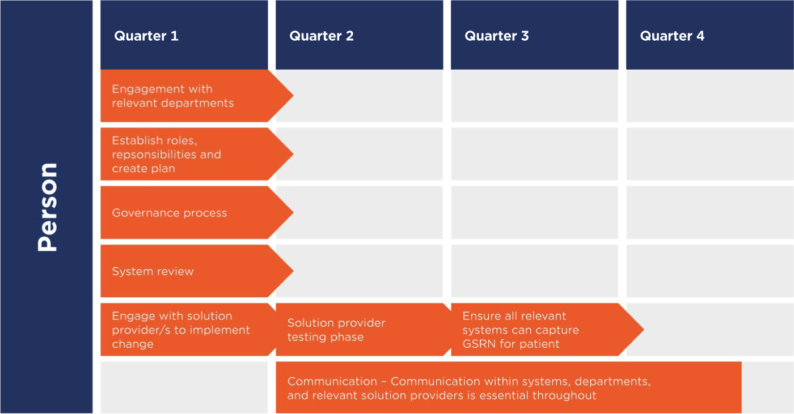
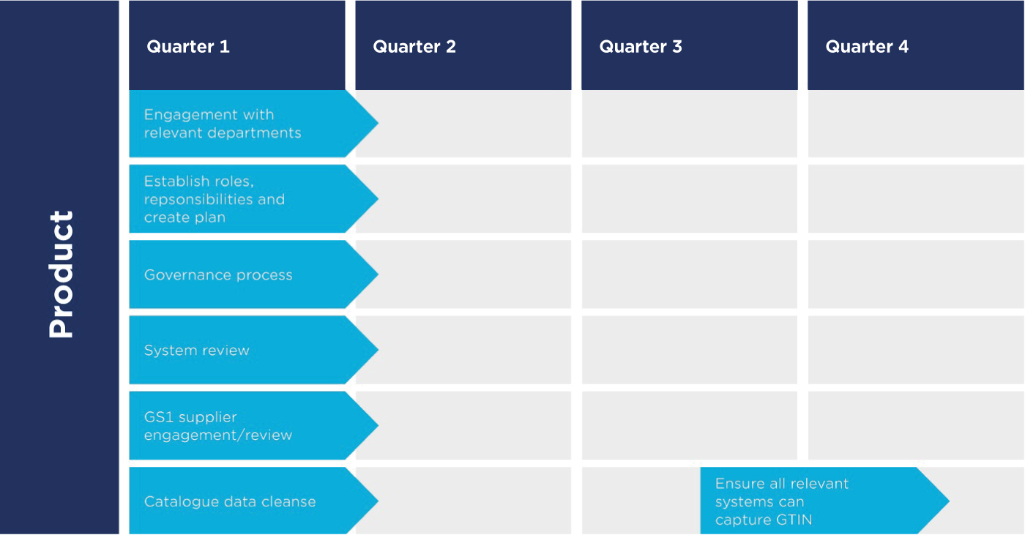

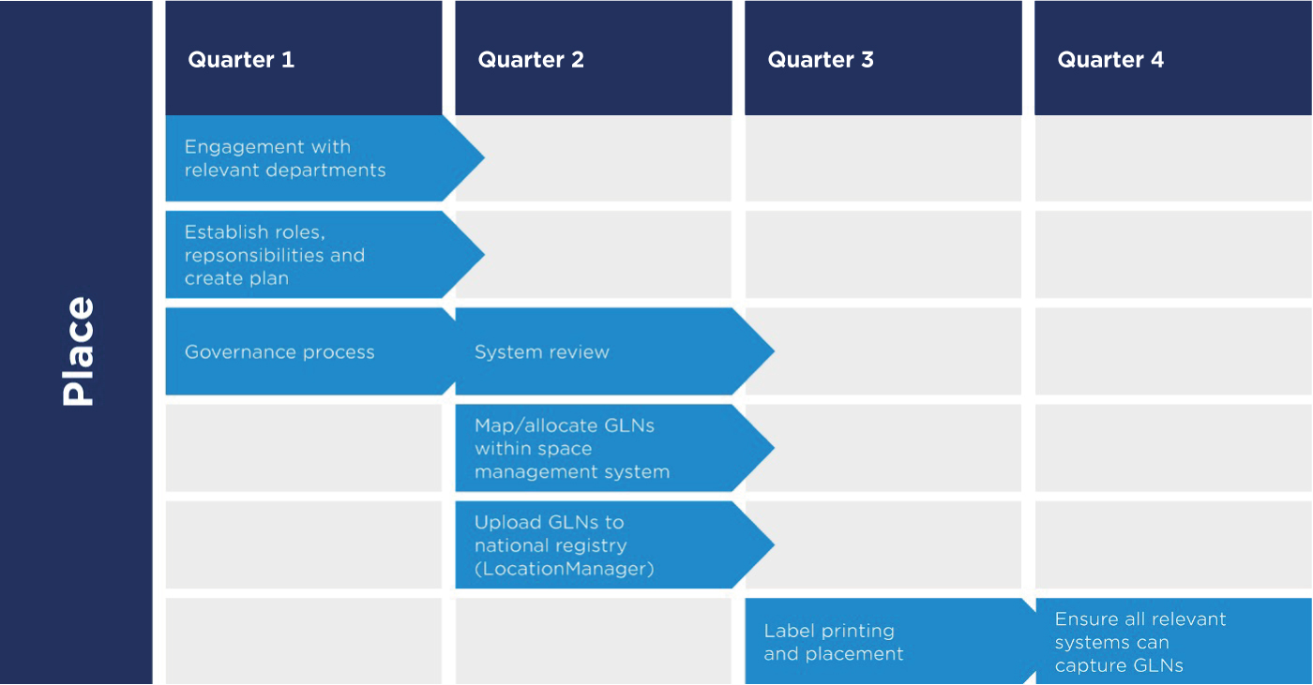

- Financial case

How will it be made affordable?
Complete the benefits calculator on the following pages.
Scan4Safety benefits calculator
 | Enabler | Context | Narrative | Indicative implementation / change cost | Indicative annual revenue cost | Organisation’s actual implementation / change cost | Organisation’s actual annual revenue cost | Estimated programme time | Organisation’s actual programme time | Organisation’s actual programme start time
Core enablers | Patient identification | All patients have GSRN (GS1 prefix and NHS number)
 | 3.1 | Upgrade PAS to include GSRN for patient and care giver
 | 3.2 | Purchase wristband printers (at £500 each)
 | 3.3 | Purchase wristband scanners (at £200 each)
 | 3.4 | Update SOPs and training
 | 3.5 | Ongoing purchase of wristbands
 | Location coding | Key driver in implementing GS1 standards
 | 4.1 | Programme to implement GLN usage across hospitals sites | All locations within a trust will need to be allocated a GLN and registered on the national NHS GLN registry – LocationManager
 | Detailed analysis and business case | Production of detailed future state architecture, costs, benefits and full business case
 | Programme execution | Programme, change and process management teams | The likely timescale to implement the above will be in the range of 12-24 months

 | Enabler | Context | Narrative | Indicative implementation / change cost | Indicative annual revenue cost | Organisation’s actual implementation / change cost | Organisation’s actual annual revenue cost | Estimated programme time | Organisation’s actual programme time | Organisation’s actual programme start time
Core enablers | Current catalogue solution/s | Key driver in Implementing GTIN from PIM
 | 1.1 | Number of 'catalogue solutions' to be integrated to the PIM | Each catalogue solutions will need to be integrated to the PIM to receive GS1 GTINs as and when available
 | 1.2 | If none in the organisation , selection and ongoing running costs of 'catalogue management' solutions | Your organisation will need a catalogue solution
 | 1.3 | Integration to PIM / catalogue solution
 | Healthcare provider internal systems and integration | Key driver in implementing GTINs, feeds to data warehouse – price intelligence
 | 2.1 | ERP GS1 readiness and capability | Each internal transactional system will need to receive a GS1 GTIN and attribute information from either the catalogue or directly from the PIM
 | 2.2 | ERP integration to PIM / catalogue solution
 | 2.3 | Inventory management solution GS1 readiness and capability
 | 2.4 | Inventory management integration to PIM / catalogue solution
 | 2.5 | Top up solution GS1 readiness and capability
 | 2.6 | Top up solution integration to PIM / catalogue solution
 | 2.7 | Pharma solution GS1 readiness and capability
 | 2.8 | Pharma solution integration to PIM / catalogue solution
- Management case

Engagement messaging for key stakeholders
Job title | Responsibility/what they care about | Why GS1 standards are important
Chief executive officer/Chief operating officer | Safe care environment that operates within its financial control total | - Accurate positive patient identification to reduce risk of errors  - Real-time patient safety alerts, thus minimising risk of financial litigation as a result of medical errors  - Reduces inventory waste by using unique product and location identifiers to trace product availability in real time
Chief financial officer/Director of finance | The organisation operates at its financial best – optimum services and minimal wastage across the organisation. Provide supporting information to chief executive re: meeting financial control totals. | - Drives operational efficiencies and reduces waste through better inventory management  - Provides accurate data capture per patient and procedure (i.e. what products/devices were used on which patient) necessary for patient-level information costings (PLICs)
Chief procurement officer/Director of procurement | Stock optimisation and visibility, reduced wastage, and product traceability for efficient recalls | - Faster product recall processes as everything tracked in real time  - Improved inventory management and visibility across organisation  - Unique ID of product and place to improve order accuracy and deliveries  - Efficient purchase to pay process with suppliers and accurate product catalogue
Chief information officer/Chief technology officer/Chief digital officer/Director of information management and technology (IM&T) | Ensures information is not held in proprietary systems – interoperability enabled and reduced manual/paper-based processes for hospital teams | - Enable data interoperability between systems and organisations through the capture and dissemination of standardised data
Medical director/Chief nurse/Surgeon/Chief clinical information officer/Chief nurse information officer | Deliver the best care possible for patients in a safe environment with reduced risk of harm. Also accurate and up to date patient care records for transparency and auditing. | - Accurate capture of data points required for the Surgical devices and Implants Information System (SDIIS)  - Reduced unwarranted clinical variation  - Safer care through traceability and auditing of patient interventions – capture of who did what to whom and when  - Reduced risk of Never Events – real-time patient safety alerts  - Efficient product recalls to minimise risk to patients  - Enable interoperability across systems and organisations  - Provides accurate data capture per patient (i.e. what was used on which patient) necessary for patient-level information costings (PLICs)  - Reduced paper-based processes to release time to care
Chief pharmacist/Senior pharmacist | Accurate medicines dispensing to prevent incorrect medicines being dispensed to patient | - Medicines identification and scanning improves closed-loop medicines supply and administration for traceability purposes and patient prescribing accuracy  - Supports the five prescribing rights: right medication, right patient, right dose, right route and right time to prevent administration errors  - Reduces risk to patient – real-time patient safety alerts
Director of estates | Efficient recording and maintenance of trust-wide locations | - The unique identification of locations to facilitate estates operations e.g. fire safety, maintenance  - Indirect benefit to procurement, clinical and asset management teams, and patients enabling product traceability – right product, right place, right time

Any systems that are GS1 UK Approved have been assessed by GS1 UK’s standards team and have been deemed capable of holding or using applicable GS1 standards. Information on systems and solutions that are GS1 UK Approved can be found on the GS1 UK website at: https://www.gs1uk.org/partner-finder
The full report Transforming NHS Pharmacy Aseptic Services in England can be found here: https://www.gov.uk/government/publications/transforming-nhs-pharmacy-aseptic-services-in-england
LocationManager – is used in the UK as a national single repository for Global Location Numbers. Further information can be found on the GS1 UK website at: https://www.gs1uk.org/our-industries/healthcare/location-management/locationmanager
Further information on the Digital Clinical Safety Strategy can be found here: https://www.nhsx.nhs.uk/key-tools-and-info/digital-clinical-safety-strategy
The full WGLL framework and the seven success measures can be found here: https://www.nhsx.nhs.uk/digitise-connect-transform/what-good-looks-like/what-good-looks-like-publication
Details on the Outcomes and Registries programme can be found here: https://www.england.nhs.uk/outcomes-and-registries-programme/
Additional information can be found in The Government Response to the Committee’s Report on Follow-up on the IMMDS report here: https://publications.parliament.uk/pa/cm5803/cmselect/cmhealth/1286/report.html
A limited number of hospitals have been identified as having limited inventory management capabilities. Further information can be found here: https://www.supplychain.nhs.uk/news-article/nhs-supply-chain-is-deploying-inventory-management-capability-into-acute-hospitals/
Full details in relation the mandate can be found here: https://www.gov.uk/government/publications/nhs-mandate-2023/the-governments-2023-mandate-to-nhs-england#:~:text=By%20March%202024%2C%20all%20trusts,can%20support%20registry%20data%20submission).
The full results of the Portsmouth barcode survey can be found here: https://www.gs1uk.org/insights/news/portsmouth-barcode-survey

